**Web Scraping and Data Visualization of India's Largest Companies**

**Internship Information**

• Domain Name : Data Analytics

• Company Name: Sharpmened Mind Technologies

Private Limited

• Instructor : Mr. Madhavan Siva

• Date : 29.09.2024

Submited By

SURIYA E

**TABLE OF CONTENT**

**1. Introduction**

1.1 Project Overview

1.2 Objectives

1.3 Scope of the Project

**2. Tools & Technologies**

2.1 Programming Language

2.2 Development Environment

2.3 Libraries Used

2.4 Web Scraping Tools

**3. Data Collection**

3.1 Web Scraping Process

3.2 Sources of Data

3.3 Handling Web Scraping Challenges

**4. Data Preprocessing**

4.1 Data Cleaning Techniques

4.2 Handling Missing and Null Values

4.3 Data Transformation and Calculations

4.4 Sample Output

**5. Exploratory Data Analysis (EDA)**

5.1 Summary Statistics

5.2 Key Trends and Patterns

5.3 Correlation Analysis

**6. Data Visualization**

6.1 Visualization Tools

6.2 Types of Visualizations

6.3 Interpretation of Visual Insights

6.4 Screen Shots

**7. Challenges and Solutions**

7.1 Web Scraping Limitations

7.2 Data Processing Challenges

7.3 Overcoming Data Visualization Obstacles

**8. Future Enhancememnts**

**9. Conclusion**

**10.References**

**1. Introduction**

This project focuses on extracting and analyzing data related to the largest companies in India. The data is sourced from Wikipedia's list of largest companies and includes key metrics such as revenue, profit, and assets. The project demonstrates how to scrape, process, and visualize data using Python libraries like requests, BeautifulSoup, pandas, and seaborn.

**1.1 Project Overview**: Describe the project's purpose, what it aims to accomplish, and its relevance in the context of data analysis or a specific domain.

**1.2 Objectives**: Clearly outline the specific goals of the project. These could be quantitative (e.g., collect data on a specific subject) or qualitative (e.g., generate insights that inform a decision).

**1.3 Scope of the Project**: Define the boundaries of the project, including what will be included or excluded, the timeframe, and any limitations in terms of data or analysis.

**2. Tools & Technologies**

This section details the technical environment in which the project is developed.

**2.1 Programming Language: Python**: Discuss why Python is chosen for this project, emphasizing its libraries and frameworks suitable for data analysis and web scraping.

**2.2 Development Environment: Jupyter Notebook**: Explain the use of Jupyter Notebook for interactive coding, data visualization, and ease of sharing results.

**2.3 Libraries Used**: List the Python libraries used in the project, such as Pandas for data manipulation, NumPy for numerical computations, and Matplotlib or Seaborn for visualizations.

**2.4 Web Scraping Tools**: Discuss any tools or libraries (like Beautiful Soup or Requests) utilized for web scraping, including their functionalities and benefits.

**3. Data Collection**

Focus on how data is gathered for analysis.

**3.1 Web Scraping Process**: Explain the methodologies employed in scraping data from the web, including the setup of scraping scripts.

**3.2 Sources of Data**: Identify the websites or online platforms from which data was collected, explaining the relevance of these sources.

**3.3 Handling Web Scraping Challenges**: Address challenges faced during web scraping, such as changing website structures or CAPTCHA, and the strategies used to overcome them.

**4. Data Preprocessing**

Detail the steps taken to prepare data for analysis.

**4.1 Data Cleaning Techniques**: Discuss methods for removing or correcting errors in the dataset, such as removing duplicates or correcting data types.

**4.2 Handling Missing and Null Values**: Describe how missing data was dealt with, including strategies like imputation or deletion.

**4.3 Data Transformation and Calculations**: Explain transformations applied to the data, such as scaling or normalization, and any calculations performed to derive new metrics.

**4.4 Sample Output:**

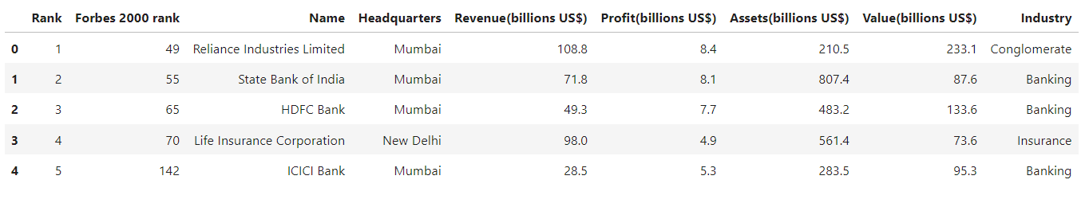

**5. Exploratory Data Analysis (EDA)**

**5.1 Summary Statistics:** Use Pandas to generate key metrics like mean, median, and standard deviation for revenue, profit, and market capitalization.

**5.2 Trends and Patterns:** Identify and analyze major trends across companies, such as revenue growth or industry dominance.

**5,3 Correlation Analysis:** Examine relationships between variables, like the correlation between revenue and profit, to uncover any significant dependencies.

**6. Data Visualization**

Discuss how data is presented visually.

**6.1 Visualization Tools**: List the tools and libraries used for creating visualizations (e.g., Matplotlib, Seaborn).

**6.2 Types of Visualizations**: Describe the types of visualizations created and their purposes.

**6**.3 **Interpretation of Insights:** Explanation of what the visualizations reveal about the data and how they contribute to understanding the underlying patterns.

**6.4 Screen Shots:**

1. **BarPlot:**

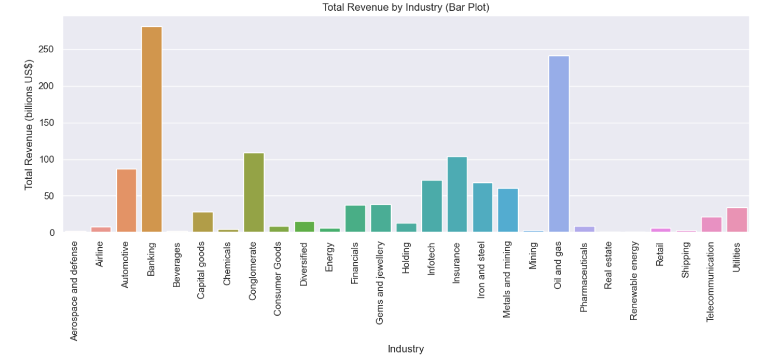

**2.Pie Chart:**

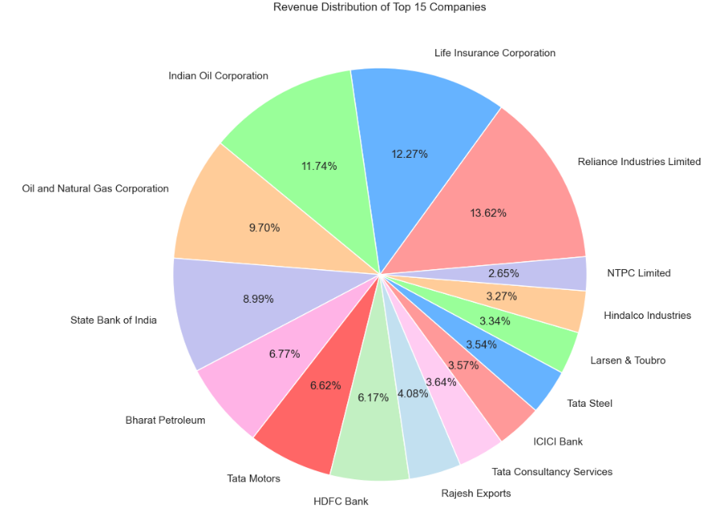

**3. Histogram Plot:**

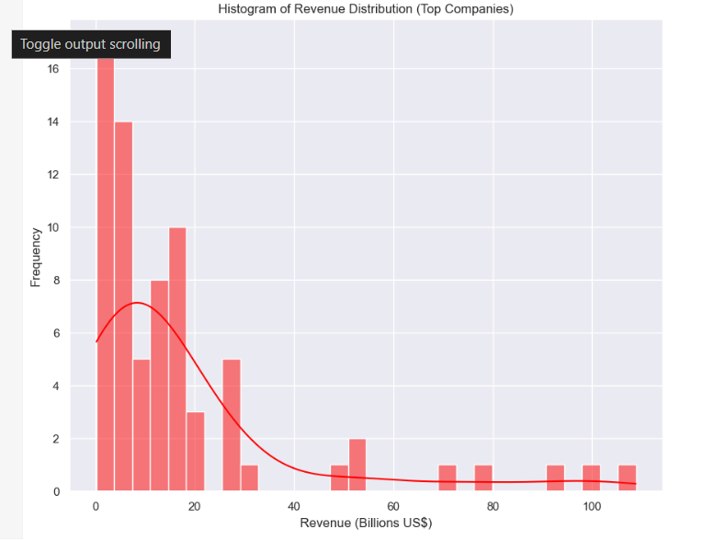

**4. Scatter Plot:**

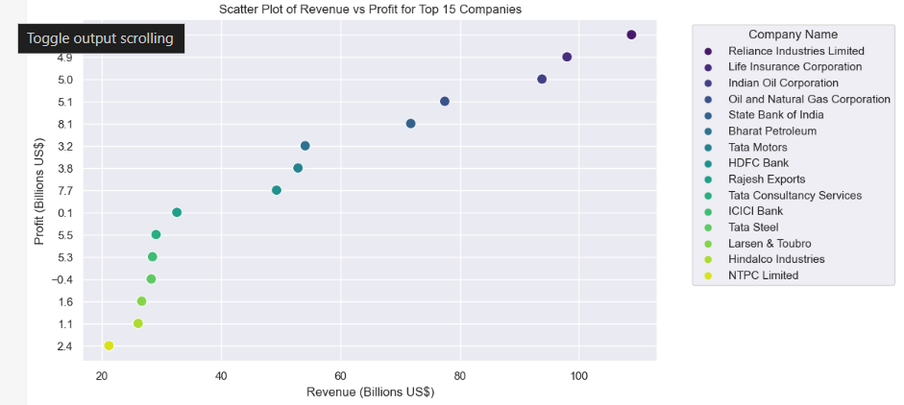

**5. Line Plot:**

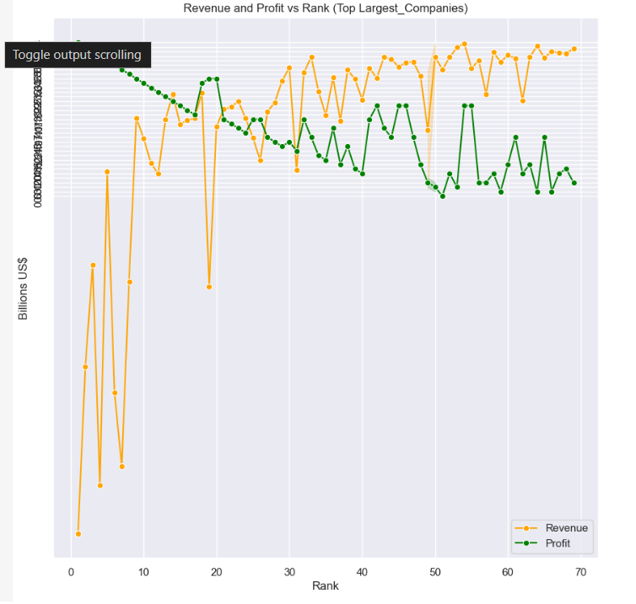

**6. Area Chart:**

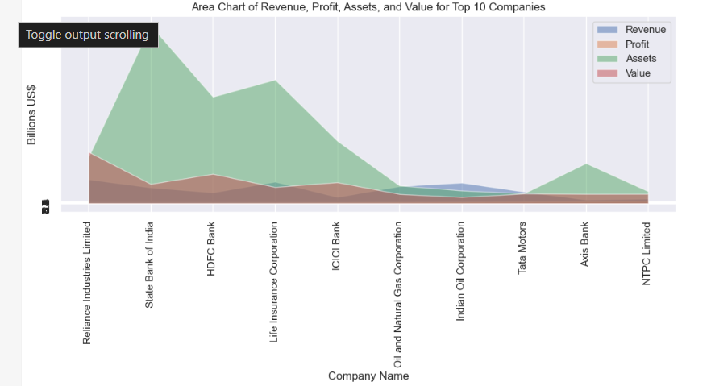

**7. Violin Plot:**

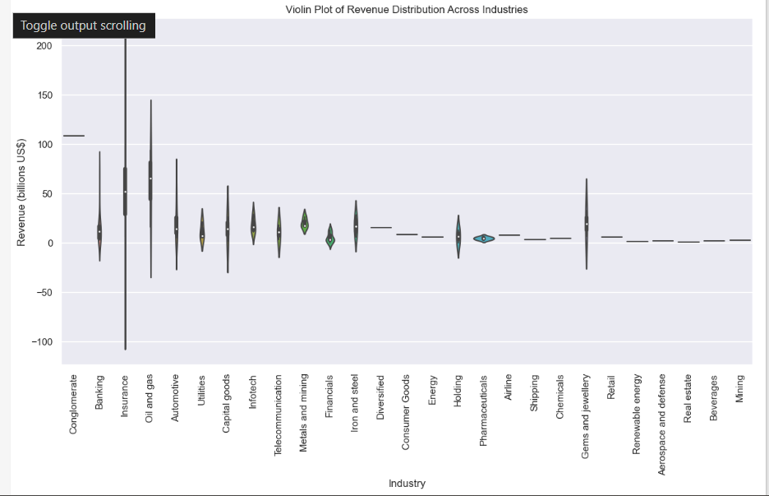

**8. Pareto Plot:**

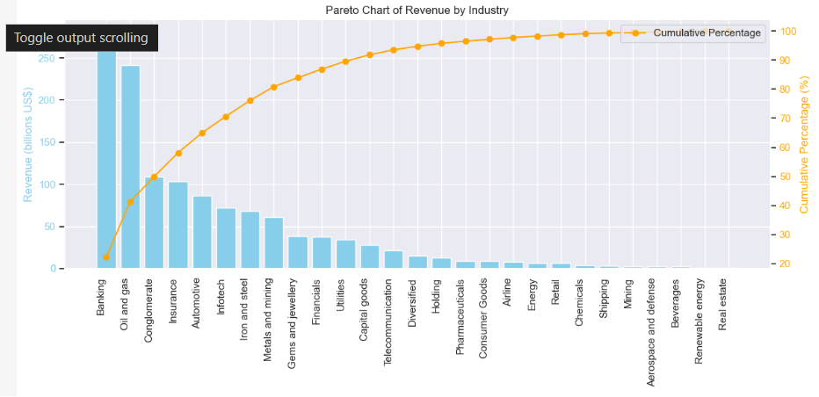

**9. Stem Plot:**

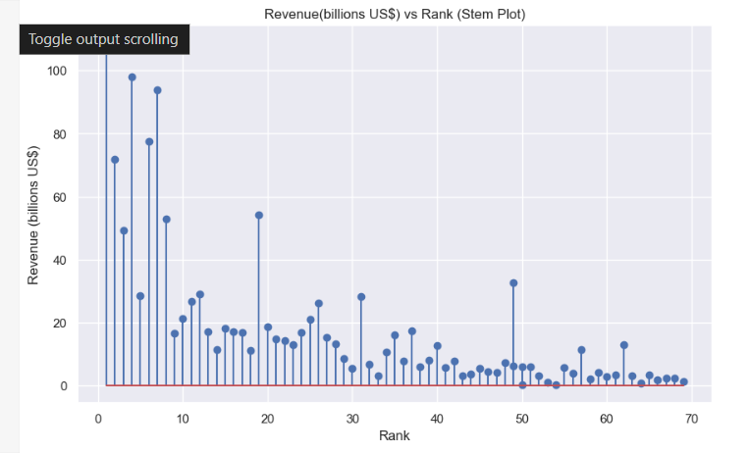

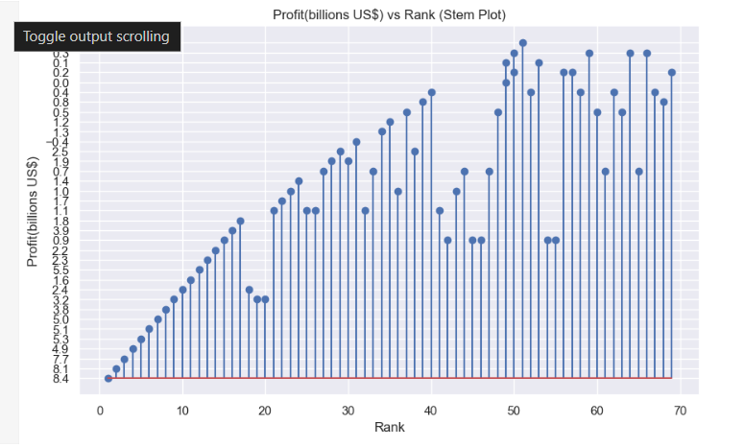

**7. Challenges and Solutions**

Reflect on the obstacles faced during the project and how they were addressed.

**7.1 Web Scraping Limitations**: Discuss specific limitations encountered during the scraping process, such as restrictions or rate limits imposed by websites.

**7.2 Data Processing Challenges**: Address challenges in data processing, such as computational efficiency or large dataset handling.

**7.3 Overcoming Data Visualization Obstacles**: Highlight any difficulties in visualizing data and the solutions implemented.

**8. Future Enhancements**

* **Real-Time Data Integration:**  
  Implement a system for continuous web scraping to keep the dataset updated in real-time, allowing stakeholders to access the most current information about company performance and market trends.
* **Sentiment Analysis:**  
  Incorporate sentiment analysis of news articles and social media mentions related to the largest companies to gauge public perception and its potential impact on stock performance.
* **Advanced Predictive Analytics:**  
  Utilize machine learning algorithms to predict future performance metrics, such as revenue growth or market trends, based on historical data and identified patterns.
* **Broader Dataset Inclusion:**  
  Expand the dataset to include additional financial metrics, such as debt-to-equity ratios, employee counts, and geographic distribution, to provide a more comprehensive view of each company’s health.
* **User-Friendly Dashboard:**  
  Develop an interactive dashboard using tools like Tableau or Dash to allow users to explore data visually, customize their views, and derive insights without needing to interact with the underlying code.

**9. Conclusion**

This project successfully demonstrated the power of web scraping and data analysis to uncover insights about the largest companies in India. Through systematic data collection, preprocessing, and exploratory analysis, we identified key trends in revenue, profitability, and market capitalization. The visualizations created provided a clear understanding of the competitive landscape and highlighted the performance of various sectors. By utilizing Python and its robust libraries, we facilitated a comprehensive and interactive reporting experience for stakeholders. These insights can inform strategic decision-making and investment opportunities. Future work could expand on these findings by incorporating real-time data and additional analytical techniques Summarize the project and its implications.

**10. References**

Compile all sources and references cited throughout the document, ensuring proper citation formats are used.

* **Github Repository :** <https://github.com/Suriya563/Web-Scraping>
* **Wikipedia (Largest Companies in India):** :<https://en.wikipedia.org/wiki/List_of_largest_companies_in_India>
* **Programming Language:**

**Python:** The primary language used for all aspects of the project, including web scraping, data analysis, and visualization.

Documentation: [Python Official Documentation](https://www.python.org/doc/)

* **Development Environment:**

**Jupyter Notebook:**  
An interactive computing environment used to write and execute Python code, visualize data, and generate reports. It was the core platform for all data analysis and reporting in this project.

Documentation: Jupyter Notebook Documentation

* **Python Libraries:**

**Pandas:**  
Used for data manipulation, preprocessing, and analysis. It allowed efficient handling of large datasets.

Documentation: Pandas Documentation

* **Matplotlib:**  
  A widely-used library for generating static, animated, and interactive plots and visualizations in Python.

Documentation: [Matplotlib Documentation](https://matplotlib.org)

* **Seaborn:**  
  Built on top of Matplotlib, Seaborn was used to create advanced and aesthetically pleasing statistical visualizations.

Documentation: Seaborn Documentation

* **BeautifulSoup:**  
  This library facilitated web scraping by parsing HTML and XML documents to extract the required data.

Documentation: BeautifulSoup Documentation

* **Requests:**  
  A Python library used for making HTTP requests to access web pages during the data collection phase of the project.

Documentation: Requests Documentation